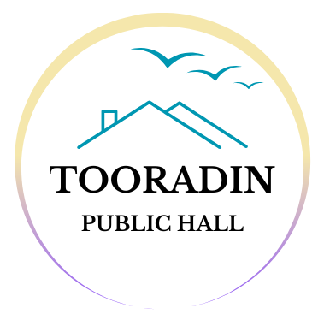

Terms and Conditions for Use of Tooradin Public Hall
Community Wellness Groups

1. Purpose of Use
- The Tooradin Public Hall (hereafter referred to as "the Hall") is to be used by the Community Wellness Group (hereafter referred to as "the Hirer") solely for the purpose of conducting wellness classes and related activities.

2. Booking and Access
- The Hirer must submit a booking request via the online booking system and receive confirmation from the Hall Committee before use.
  - All details must be entered into the booking request to be valid.
  - A minimum of 1 week notice must be given via email - info@tooradinpublichall.com - of any amendment or cancellation of booking.
- Booking types are as follows
  - Class times – 1 hour minimum
    - 30 minutes will be provided either side of your booking for set up and pack up.
  - Event times – 5 hour block
    - 1 hour will be provided either side of your booking for set up and pack up.
- Access to the Hall is granted only during the agreed booking times.
- Storage space may be available upon request.
- The Hirer is responsible for ensuring all members, participants, and guests comply with entry and exit times.

3. Fees and Payments
- Usage fees are to be paid via direct transfer using the details provided on the electronic invoice by the date advised.
- Full payment of the invoice is required if a booking cancellation is not notified per clause 2.1.b)
- Late payment of invoices will incur a $25.00 fee
- Monthly storage fees apply to each storage space hired.
- Any additional charges incurred (e.g., for extra cleaning, damage repairs, or overtime use) will be invoiced separately and must be paid within 14 days.

4. Conduct and Responsibility
- The Hirer agrees to use the Hall in a respectful, safe, and responsible manner.
- The Hirer is responsible for the behaviour of all participants and attendees.
- Noise levels must be kept at a reasonable level to avoid disturbance to nearby residents.

5. Care of Facilities
- The Hirer agrees to leave the Hall in a clean and tidy condition after each use.
  - Cleaning supplies can be found in the cleaning cupboard near the toilets.
  - All floors must be swept/vacuumed after each booking.
  - All floors must be mopped upon the final booking of the week.
  - Toilets must be checked to be in good, clean working order after each class and/or event booking.
- All rubbish must be placed in designated bins.
  - Wheelie bins may be required to be placed along the roadside for collection before Friday mornings.
  - Please return them to the bin cage if they are still roadside at your next booking, after Friday.
- Tables and chairs must be returned to their respective rooms.
  - Chairs must not be stacked higher than 8 – 9 chairs high.
- All kitchen accessories must be returned to their correct cabinets and/or drawers.
- Any damage to the Hall or its property must be reported via email - info@tooradinpublichall.com - immediately to the Hall office bearer, along with supporting photos.
  - The Hirer will be held liable for the costs of repairs or replacements where damaged has been a result of the booking.
- Any maintenance requests must be reported via email - info@tooradinpublichall.com - to the Hall office bearer at your earliest convenience, along with supporting photos.

6. Insurance and Liability
- The Hirer must maintain appropriate public liability insurance and provide proof of coverage.
- The Hall Committee accepts no responsibility for loss, theft, or damage to personal property brought into the Hall.
- The Hirer indemnifies the Hall Committee against any claims arising from the Hirer's use of the Hall.

7. Compliance with Laws
- The Hirer must comply with all applicable local, state, and federal laws and regulations, including fire safety.
- Emergency exits must always remain clear.
  - There are 3 emergency exits at the Hall.
    - The main entrance out to the driveway.
    - The dining room out to the carpark.
    - The main hall out to the road.
- The emergency evacuation meeting point is located on the other side of Tooradin Station Road, at the picnic tables along the inlet.

8. Termination of Use
- The Hall Committee reserves the right to cancel or terminate the Hirer’s booking or ongoing use of the Hall for breach of these terms and conditions, or if the Hall is required for emergency use.

9. Amendments
- These Terms and Conditions may be amended from time to time by the Hall Committee, with reasonable notice (no less than 30 days) given to the Hirer.
  - Most amendments will take effect on either January 1st or July 1st unless otherwise advised.

10. Agreement
- By signing below, the Hirer agrees to comply with these Terms and Conditions for the use of the Tooradin Public Hall.

Signed for and on behalf of the Community Wellness Group.

Name: Click or tap here to enter text.

Position: Click or tap here to enter text.

Date: Click or tap to enter a date.

